Energy Harvest Board Voltage plot

1. Case Study: Harvester with output voltage > VIN

Set up:

1. Given 3.3V power source, connect 3 diodes (100V 15A R-6) in series to decrease the input voltage(Solar In) to 3.0V.
2. Connect the 3.0V power source to Solar In and the voltage on Solar In get 1.887V
3. Before connect energy harvest board to battery, the EXT BAT get 1.734V
4. After connect energy harvest board to battery, the EXT BAT get 3.3V

Plot in document:

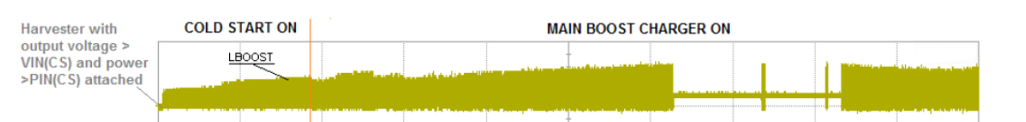

Data collected from 30 mins testing:

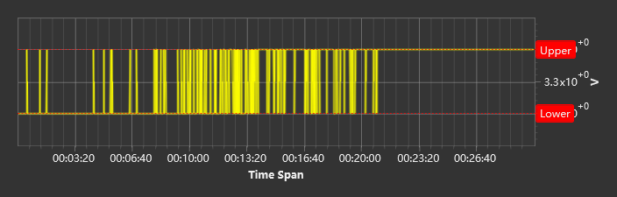



1. Case study: V Bat plot for charging

Set up:

1. Given 3.3V power source and connected it to Solar In.
2. Before connect battery, EXT BAT get 3.979 V.
3. After connect battery, EXT BAT get 3.668V at beginning.

Plot in document:

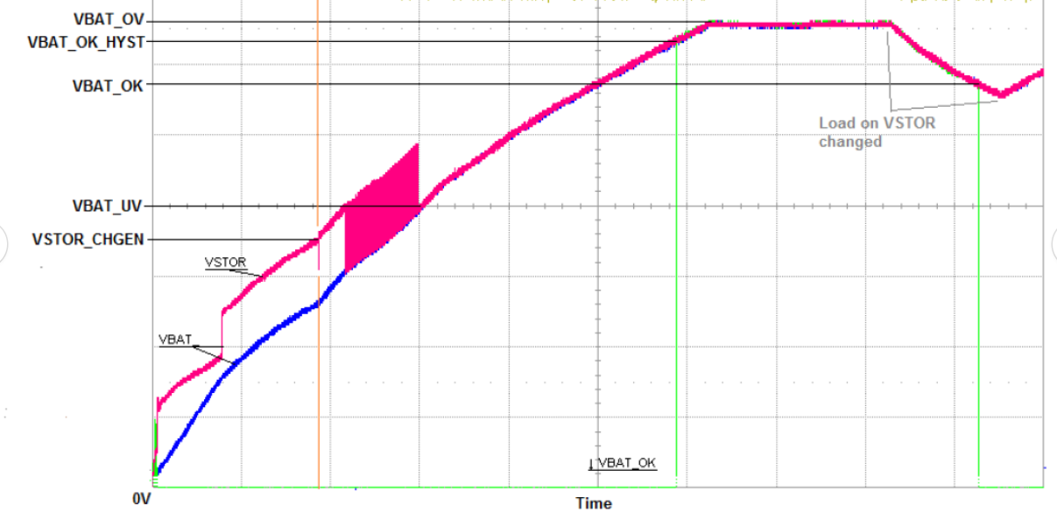

Data collected from 15 mins testing:

